**Lab #5 Answers**

**CECS 378 – Spring 2021 – Cappel & Uuh**

**Due:** Wednesday, March 22nd by 11:59 PM

**Screen Shot 1)** Take a screen shot of your activated Metasploit web interface.

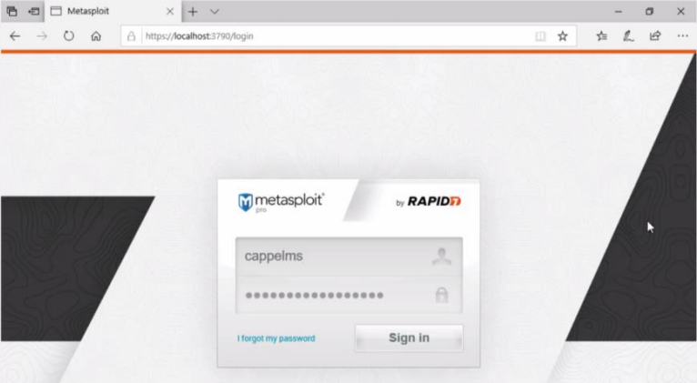

**Screen Shot 2)** Take a screen shot of your running Metasploit2 machine showing the Metasploit graphic.

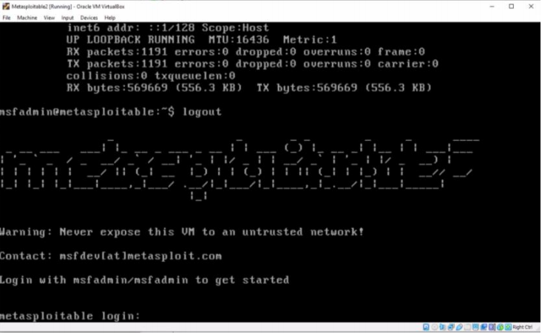

**Screen Shot 3)** Take a screen shot of the scan engine information.

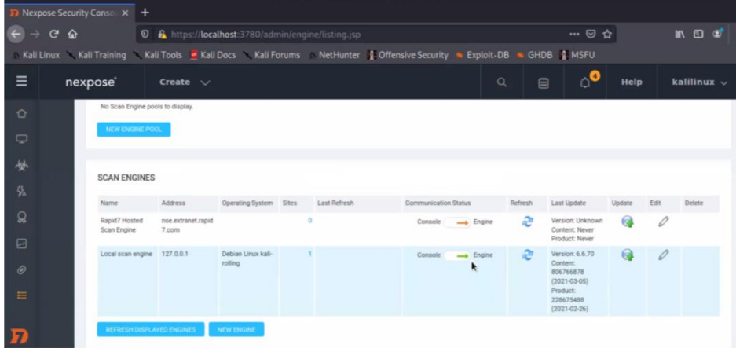

**Question 1)** How many vulnerabilities were found on the Metasploitable2 virtual machine?

There were 337 vulnerabilities found on the Metasploitable2 virtual machine.

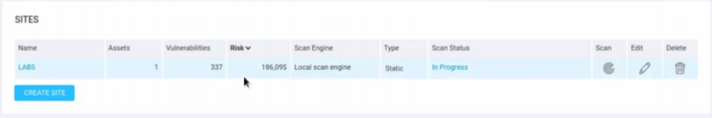

**Screen Shot 4)** Take a screen shot of the open ports found with nmap.

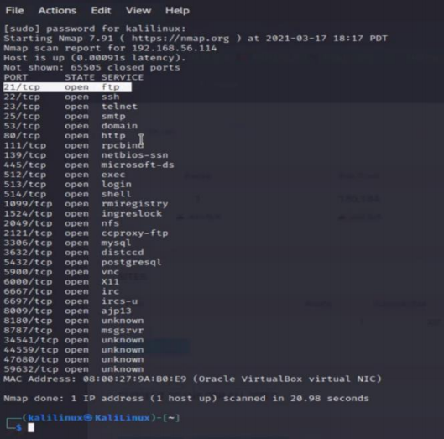

**Screen Shot 5)** Take a screen shot of a portion of the shadow file containing the hash of the root account.

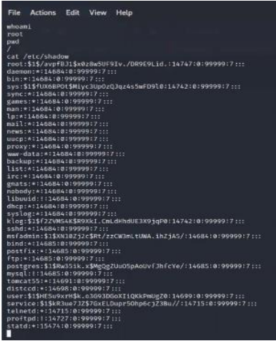

**Screen Shot 6)** Take a screen shot showing the Discovery section.

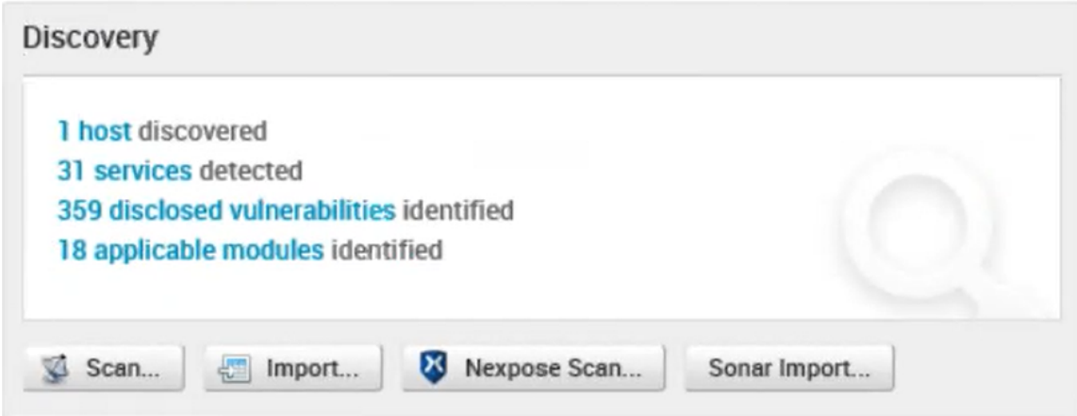

**Screen Shot 7)** Take a screen shot showing the Penetration section.

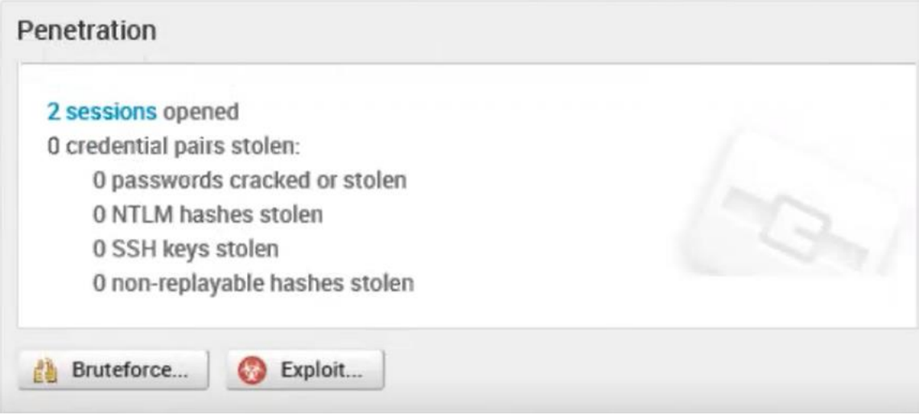

**Screen Shot 8)** Take a screen shot showing the Active sessions.

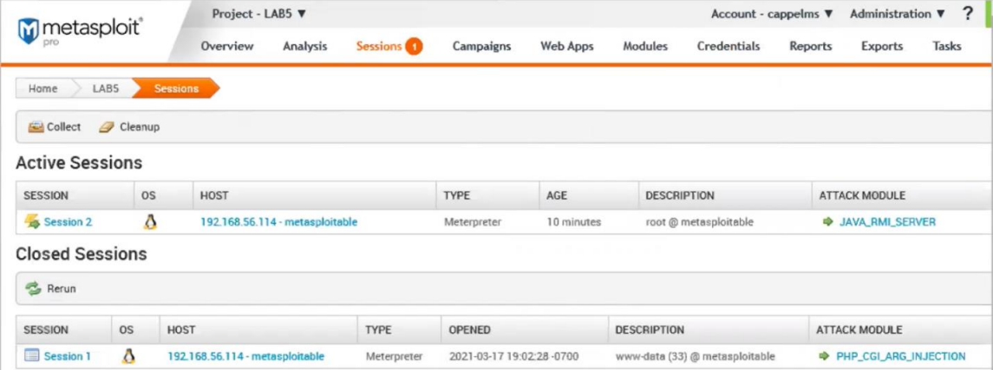

**Screen Shot 9)** Take a screen shot showing some of the active processes running on Metasploitable2.

